**Apple Automation**

Apple automation is the process of reducing the amount of work and time a designer has to spend on banner production, by streamlining the workflow and leveraging the power of Photoshop’s programming capabilities.

The automation files live in a shared folder called ‘Fetch-US-Automation’ in the Creative Cloud to act as a centralized repository for the whole process.

The process is split into three parts, as per the required banners for Apple: Static, Rolling and WhiteTail. Each of these processes has a base PSD template with corresponding subset PSDs, which have been carefully set up to work with the automation script (do not rename any key layer names, as this will break the script). Which of these processes you run, is dependant on what parameters you set in the .CSV file. The CSV file is also used for defining the copy required in the banners.

**CSV File**



The above is an example entry in the CSV file for exporting all the different banner types across Static, Roller and WhiteTail. The various steps each process takes is separated by a semicolon. For example, STATIC specifies that the script must use the StaticLeft.psd, the StaticMiddle.psd and the StaticRight.psd when swapping out assets. It also specifies the main copy “Millions of tracks available(…)”, and then specifies the CTA copy “Try Apple Music free(…)” followed by the Terms copy “Terms Apply.” When there are two semicolons together, it means the script will skip that step of the process.

To insert a line break in the copy, insert the tilde (~) character where necessary. In the above example for the Static banner, there are two tilde characters, which will separate the copy over three lines.

If you only want to export Static, WhiteTail, or one of the Roller sizes, then you only need to include that line. Alternatively, you can add an ‘X’ character at the end of ‘STATIC’, ‘ROLLER’, or ‘WHITETAIL’ and the script will ignore that line completely. In the above example, it will ignore WhiteTail instructions, as it reads ‘WHITETAILX’.

**The basic outline of how to complete the process is as follows:**

1. Upon receiving an Apple brief along with the assets, check if there is a corresponding country folder in the process type directory (e.g. ~/Layout/Rolling/Russia or ~/Layout/Static/India).
   1. If yes, open the placeholder PSD(s) and insert the new assets. Save & close.
   2. If no, copy an existing country folder, rename it accordingly and open the placeholder PSD(s) and insert the new assets. Save & close.
2. Open the ProcessAll V1.csv file, located in /Layout/Automate/main , with a plain text editor like TextEdit.app – it is important you DON’T open this file with Excel, as it will “corrupt” the file.
3. Create a new entry in the file, or edit an existing one, for the country(ies) you are planning to export banners for. Save & close.
4. Open the ProcessAll(WhiteTail)_RC_Clean.jsx file, located in the same directory as the CSV file, with the (Adobe) ‘ExtendScript Toolkit.app’.
5. Launch Photoshop, but do not open any files.
6. Go back to the ExtendScript app, select Photoshop from the dropdown menu and make sure the chain icon is green – this is to ensure the two applications can ‘see’ each other.

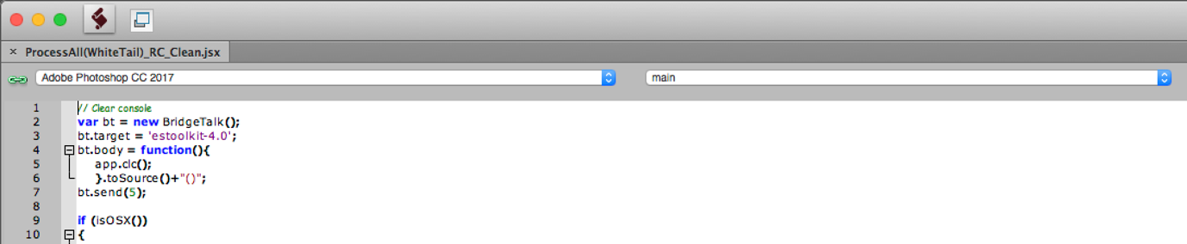

1. Press the ‘play’ icon located to the right of these two dropdowns to run the script.

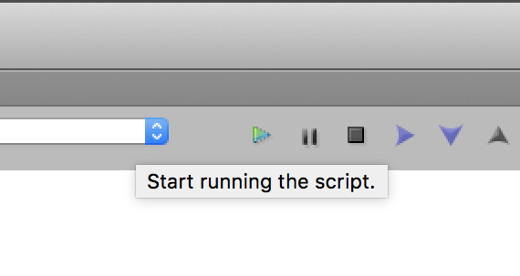

1. When the script begins running, it should switch you to Photoshop, where it will prompt you to select a CSV file. Navigate to the ‘Fetch-US-Automation’ folder in the Creative Cloud, and select the ProcessAll V1.csv

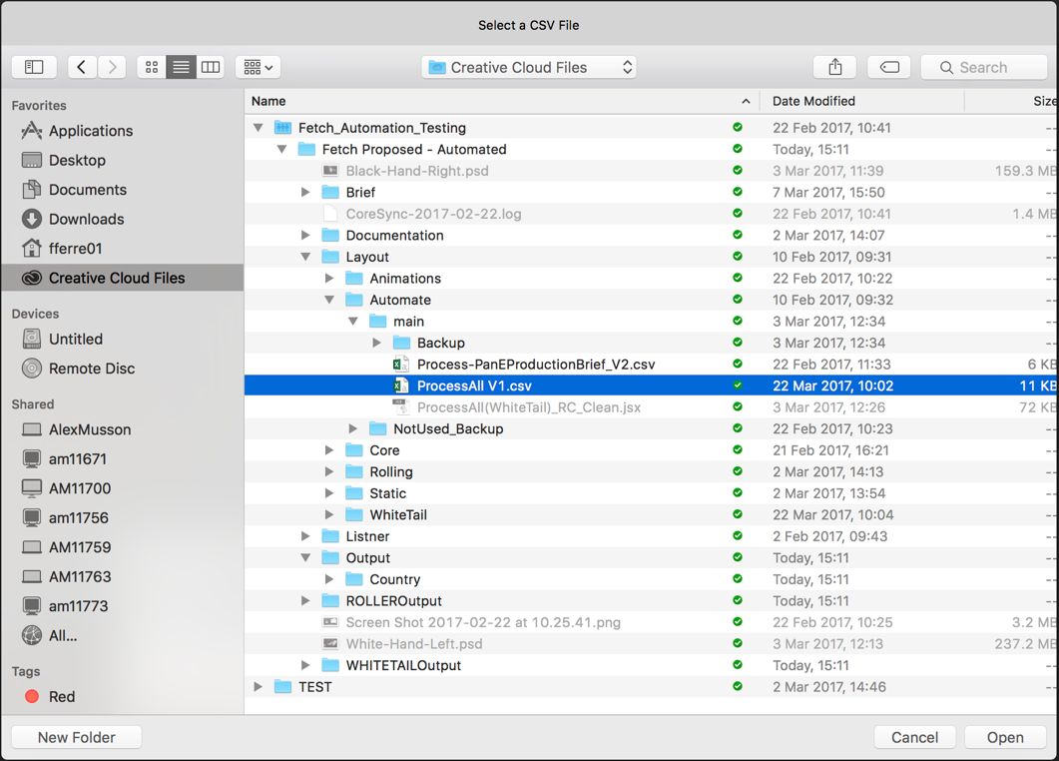

1. The script should then begin to automatically open the PSD template for whichever banner types you specified in the CSV file, like Static, Rolling or WhiteTail, and begin to update the template with the assets you inserted in the placeholder PSDs; and update any copy accordingly. At the end of this process you will be prompted to define the settings to export the artboards. Click ‘browse’ and select the country directory so that the files are exported to the correct location.

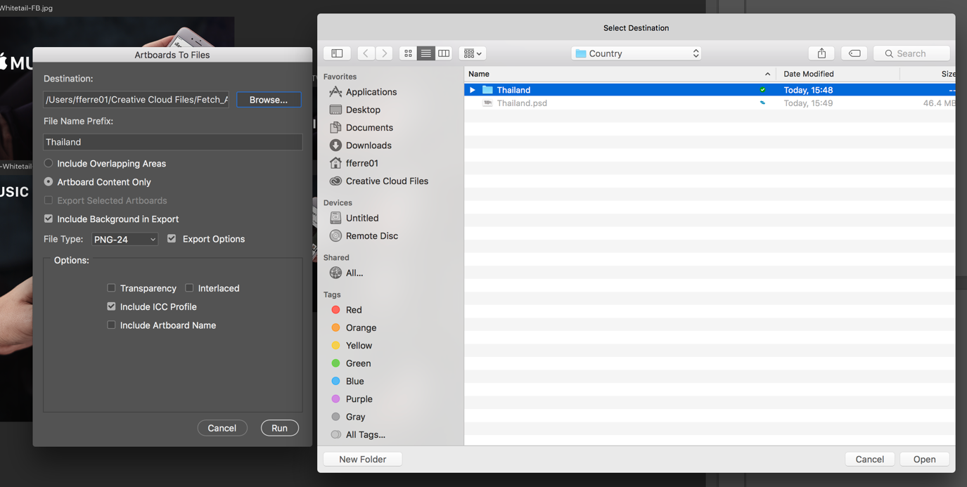

1. The script will export the assets to specific output directories. ‘Output’ = Static banners, ‘ROLLEROutput’ = Roller banners, ‘WHITETAILOutput’ = WhiteTail banners.

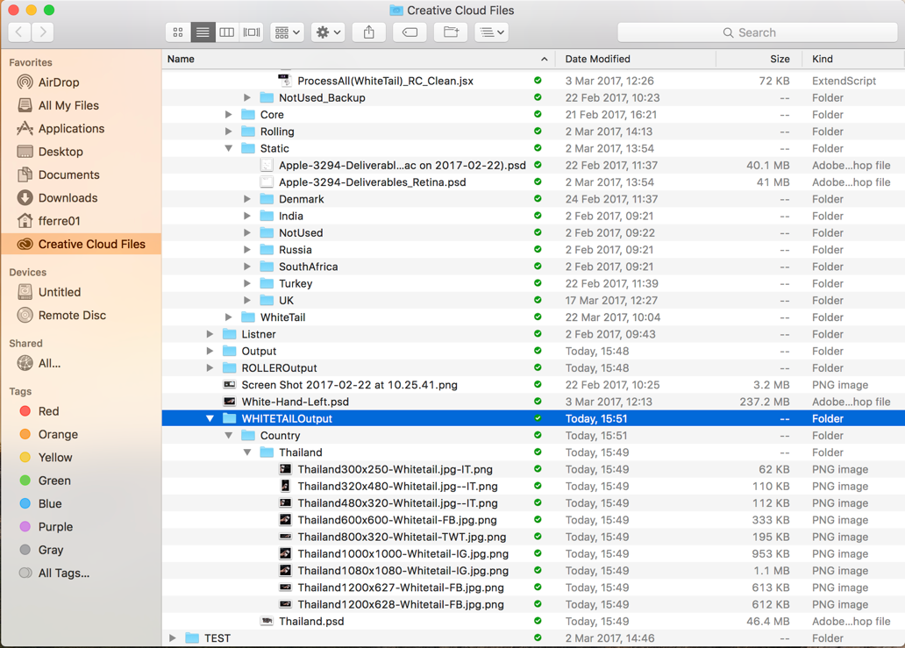

1. And that’s it! Copy any finished deliverables across to a separate location (e.g. your desktop) before running the script again, as the first step of the script is to **erase all content** in the output folders before continuing.

1. The automation workflow is based on a shared folder in Creative Cloud. This folder hosts the script and logic, to make sure that everything is process when required (both inside and for out side freelancers (when required)

2. The clean script is ProcessAll V4.jsx and is available under Layout / Automate / Main (and documented, as there are a couple of pre-reqs and what each function does. Don’t worry about the length, as most of the script has been generated from Photoshop via the Listener (which I will give you tomorrow. All I’ve written is the logic for the steps and control elements).

3. The CSV file which should be processed is called ProcessAll V1.csv and is under the same folder

(Currently it’s set to run Static and Rolling for India, Whitetail is described yet, but not yet implemented in the Script

4. File Definitions for Static, Rolling and WhiteTail are stored under Layout / Automate (under the same names)

5. STATIC (Referred to from the CSV file)

This contains the core PSD (Apple-3294-Deliverables_Retina.psd) that each country is created from. I have created the Retina version as this contains new art boards to cater for the retina as well as the standard screens (you should get better quality here, as opposed to the current workflow). Image assets for each country (i.e. StaticLeft, StaticMiddle and StaticRight screens) come from each country folder location under STATIC. I.e. for India they are labeled / Static / India / StaticLeft.PSD, StaticRight.PSD and StaticMiddle.PSD. The idea is that the designer works with these files for each country and gets the artwork correct for each country defined in the CSV file. When the script runs, it will load the main PSD file (Apple-3294-Deliverables_Retina.psd) and will create entries for each country, by substituting each Left/Middle and Right PSD file within the country definition. In the script Photoshop will run the Export Artboards function, which requires the operator to enter the country code and press enter twice.

Within the CSV file, just define the countries, and the script will create the required output dimensions for each country.

For each PSD file, there might be text that needs to be replacing in the PSD for each country. Specific this in the CSV file (Copy , CTA Copy and Terms), in the specified locations. These will be injected to the PSD’s at script run time. For copy, As this can run over multiple lines, the originating text should be one single entity, but where you would like a carriage return in the text, specify a tilde sign i.e. Millions of tracks~available whenever you~want. wherever you are (will run over three lines).

6. ROLLING (Reffered from the CSV file). The format is the same for STATIC. Each country is derived from a single folder structure (Layout / Rolling / )

This folder contains the core PSD’s for each size of video that will need to be created. i.e. 320x480.psd. This file will describe the file size for each country defined in the CSV file under the ROLLING keyword

The right hand panel is the moving panel and is defined in the file RollingRight.psd, but derived from the files Position1.psd to Position4.psd, these are located under Layout / Rolling / Country code / Anim Positions (as these are specific to each country). The designer just needs to maintain the Position1.psd to Position4.psd files, the script will do the rest.

The ROLLING files have static images as well, these can be found under Layout / Rolling / Country Code / AnimStatics and are called AnimLeft.psd and AnimRight.psd and are referred to in the CSV file for each file size definition. The script will create a set of files for each country for each size type (for both MOV and GIF)

7. WTail - Needs implementing, but as you can see won’t be to difficult.

For each main PSD file (video size file, as well as the retina PSD) everything has been converted to Linked Smart Objects, this makes the files much smaller and easier to maintain. Also, it will free the designer from opening the files every week (and hopefully only need to be opened on refresh or template change). The script will look after the dynamic replacement of content as defined in the CSV file.

RC – May 2017 – Update the code to take into consideration the limited output file size. The code will now open up any JPG / PNG file if it’s over the specified file size in the CSV controller file. This will allow the user to refne the output file size and optimise where required.